3/1/2025

VEERABABU

SASI INSTITUTE OF ENGINEERING AND TECHNOLOGY

DEVOPS ASSIGNMENT-1

MID EXAMINATION ANSWERS

**DevOps Assignment -1 23K65A0507**

**Set-1**

**1 . Explain importance of Agile software development. [10M]**

**A. Agile software development is a methodology that emphasizes flexibility, collaboration, and customer satisfaction. It has become a cornerstone of modern software development due to its numerous benefits and adaptability to changing requirements**

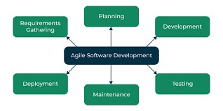

⮚ **Agile is important:**

**1 . Customer-Centric Approach:**

**Agile prioritizes customer satisfaction by delivering working software in small, incremental releases.**

**2. Adaptability to Change:**

**Agile embraces changing requirements, even late in the development process.**

**3.Faster Time-to-Market:**

**By breaking projects into smaller, manageable iterations (sprints), Agile enables faster delivery of functional software.**

1. **Improved Quality:**

**Agile promotes continuous testing and integration throughout the development process.**

1. **Enhanced Collaboration and Communication:**

**Agile fosters teamwork and open communication among cross-functional teams, stakeholders, and customers.**

1. **Risk Management:**

**Agile mitigates risks by delivering incremental results and allowing for frequent adjustments.**

1. **Increased Productivity and Efficiency:**

**Agile empowers teams to self-organize and take ownership of their work.**

**8.Transparency and Visibility:**

**Agile provides stakeholders with clear visibility into project progress through tools like Kanban boards and burndown charts.**

1. **Scalability:**

**Agile frameworks like Scrum, Kanban, and SAFe (Scaled Agile Framework) can be scaled to suit projects of varying sizes and complexities.**

1. **Focus on Business Value:**

**Agile prioritizes delivering features that provide the highest business value.**

—---------------------------------------------------------------------- **2 . Explain DevOps architecture and its features with a neat sketch. [10M] A.DevOps is a cultural and technical approach that combines software development (Dev) and IT operations (Ops) to improve collaboration, automation, and efficiency in delivering software. The architecture of DevOps is designed to streamline the software development lifecycle (SDLC) by integrating tools, processes, and practices.**

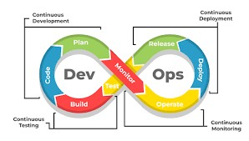

**The DevOps architecture typically consists of the following components:**

**1.Development Phase:**

**Developers write code and commit it to a version control system (e.g., Git).**

**2.Testing Phase:**

**Automated testing tools (e.g., Selenium, JUnit) are used to validate the code.**

**3.Deployment Phase:**

**Continuous Deployment (CD) tools (e.g., Kubernetes, Docker, Ansible) automate the deployment process.**

**4.Monitoring and Feedback:**

**Monitoring tools (e.g., Prometheus, Nagios) track application performance and infrastructure health.**

**Key Features of DevOps Architecture:**

**1.Collaboration:**

**Breaks down silos between development and operations teams.**

**2.Automation:**

**Automates repetitive tasks like testing, deployment, and infrastructure provisioning.**

**3.Continuous Integration (CI):**

**Developers frequently merge code changes into a shared repository.**

**4.Continuous Delivery (CD):**

**Ensures that code is always in a deployable state.**

1. **.Infrastructure as Code (IaC):**

**Manages infrastructure using code and automation tools.**

1. **.Monitoring and Logging:**

**Real-time monitoring of applications and infrastructure.**

1. **.Scalability and Flexibility:**

**Supports scalable and cloud-native architectures.**

1. **.Security (DevSecOps):**

**Tools like SonarQube and OWASP ZAP ensure secure code and infrastructure.**

—---------------------------------------------------------------------- **3 . Describe various features and capabilities in agile. [10M]**

**A. Features and Capabilities of Agile**

**Agile is a flexible and iterative approach to software development that focuses on delivering value to customers through collaboration, adaptability, and continuous improvement.**

1. **Iterative and Incremental Development:**

**Agile breaks projects into small, manageable iterations (sprints) that typically last 1-4 weeks.**

1. **Customer Collaboration:**

**Agile emphasizes close collaboration with customers and stakeholders throughout the development process.**

1. **Adaptive Planning:**

**Agile plans are flexible and can adapt to changing requirements, even late in the development process.**

1. **Cross-Functional Teams:**

**Agile teams are self-organizing and cross-functional, meaning they include members with diverse skills (e.g., developers, testers, designers).**

1. **Continuous Delivery:**

**Agile focuses on delivering working software frequently, often at the end of each sprint.**

1. **Emphasis on Working Software:**

**Agile prioritizes delivering functional software over comprehensive documentation.**

1. **Regular Feedback Loops:**

**Agile incorporates feedback at multiple stages, including daily stand-ups, sprint reviews, and retrospectives.**

1. **Transparency and Visibility:**

**Agile promotes transparency through tools like Kanban boards, burndown charts, and daily stand-ups.**

1. **. Continuous Improvement:**

**Agile encourages teams to reflect on their processes and performance through regular retrospectives.**

1. **. Prioritization of Value:**

**Agile uses techniques like backlog grooming and MoSCoW prioritization ( Must-have, Should-have, Could-have, Won’t-have) to focus on high-value features.**

1. **. Scalability:**

**Agile frameworks like Scrum, Kanban, and SAFe (Scaled Agile Framework) can be scaled to suit projects of varying sizes and complexities.**

1. **. Risk Management:**

**Agile mitigates risks by delivering incremental results and allowing for frequent adjustments.**

1. **Empowerment and Ownership:**

**Agile empowers teams to make decisions and take ownership of their work.**

1. **Focus on Quality**

**Agile integrates testing and quality assurance throughout the development process.**

**—------------------------------------------------------------------------------------------------------------------------------**

**Set-2**

**1. What is SDLC? Explain various phases involved in SDLC. [10M] A  . Phases Involved in SDLC:**

**The SDLC typically consists of several distinct phases. Each phase has its specific purpose and deliverables, and they are often carried out sequentially, although modern methodologies like Agile may involve iterative development and overlapping phases.**

1. **Requirement Gathering and Analysis:** 
   * **Purpose: This is the first phase where the business requirements are gathered and analyzed. The goal is to understand what the client or user needs from the software.**
2. **System Design** 
   * **Purpose: This phase focuses on designing the software solution based on the requirements gathered in the previous phase.**
3. **. Implementation (Coding)** 
   * **Purpose : This is the phase where the actual code for the software application is written.**
4. **. Testing** 
   * **Purpose : Testing is done to ensure the software is free from bugs and meets the functional and non-functional requirements.**
5. **. Deployment** 
   * **Purpose: After successful testing, the software is deployed to the production environment for end-users to access and use.**

**6. Maintenance**

● **Purpose : The software requires ongoing maintenance to fix bugs, add features, or update it for security reasons after deployment.**

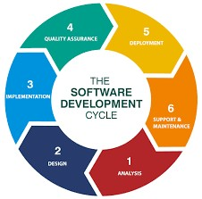

**2. Explain briefly about various stages involved in the DevOps pipeline.**

**[10M]**

**A. The DevOps pipeline is an automated, continuous integration and continuous delivery (CI/CD) pipeline that enables rapid and efficient development, testing, and deployment of software.**

**B.** 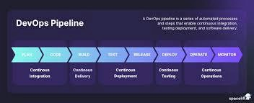

# 1 . Source Code Management

* **Purpose : This is the initial stage where developers write the source code of the application.**
* **Activities :**

**o Developers write, update, and manage the source code using version control systems (VCS) like Git ( GitHub, GitLab, Bitbucket).**

* **Tools : Git, GitHub, GitLab, Bitbucket.**

# 2 . Continuous Integration (CI)

* **Purpose: This stage involves integrating code from various developers into a shared repository regularly.**
* **Activities:** 
  + **The committed code is automatically retrieved from the repository and built.**
  + **Tools : Jenkins, CircleCI, Travis CI, GitLab CI, Bamboo**

# 3. Automated Testing

* **Purpose: To ensure that the code is correct, functional, and doesn't break existing features.**
* **Activities:**

**o Unit tests, integration tests, and functional tests are executed automatically.**

* **Tools: Selenium, JUnit, TestNG, Postman, Cypress.**

# 4. Continuous Delivery (CD) / Continuous Deployment (CD)

* **Purpose: Automating the delivery of code to various environments (staging, production) for release.**
* **Activities:**

**o After passing automated tests, the application is deployed to staging or testing environments for further validation.**

* **Tools: Jenkins, Spinnaker, Azure DevOps, AWS CodePipeline.**

# 5 . Configuration Management

* **Purpose : To ensure consistent environments across development, staging, and production.**
* **Activities :**

**o Infrastructure and environment configurations are automated using Infrastructure as Code (IaC) practices.**

* **Tools : Ansible, Chef, Puppet, Terraform, SaltStack.**

# 6 . Monitoring and Logging

* **Purpose : This stage ensures that the application runs smoothly in production, identifying and solving issues proactively.**
* **Activities :**

**o Continuous monitoring of applications and infrastructure to track system health and performance.**

* **Tools : Prometheus, Grafana, ELK Stack (Elasticsearch, Logstash, Kibana), Nagios, Datadog, Splunk.**

# 7 . Feedback and Continuous Improvement

* **Purpose: To use feedback from production to drive improvements and enhancements in the software.**
* **Activities:**

**o Collect feedback from users, stakeholders, and monitoring tools.**

* **Tools: Jira, Trello, Slack, User Feedback Tools.**

# 8. Deployment to Production

* **Purpose: To ensure that the application is released to the production environment with minimal downtime and risk.**
* **Tools: Kubernetes, Docker, Helm, AWS Elastic Beanstalk, OpenShift.**

**—-------------------------------------------------------------------------------------------------------------**

**3. Describe the phases in DevOps life cycle. [10M]**

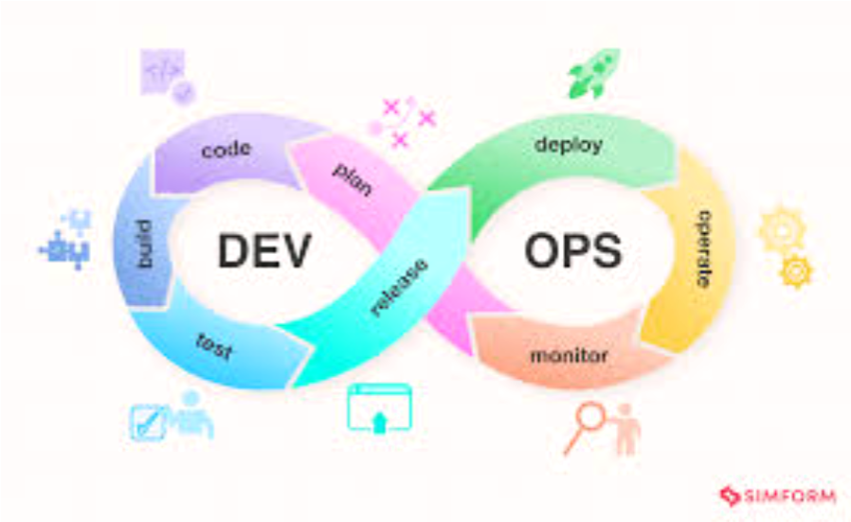

The DevOps lifecycle has several phases, including continuous development, continuous integration, continuous testing, continuous deployment, continuous feedback, continuous monitoring, and continuous operations.

Continuous integration

* Involves merging code changes into a shared repository
* Uses automated builds to verify each checkin or branch

Continuous testing

* Involves automating testing activities to validate software changes
* Provides feedback to the development team

Continuous monitoring

* Involves observing, measuring, and analyzing the performance of software applications

●

* Helps developers find patterns and parts of the program that need more attention

Continuous feedback

* Involves providing opportunities for feedback on how the development process could be improved

●

* Helps build the best version of an application.

Continuous operations

* Involves automating launch and release processes, and spotting errors immediately
* Helps ensure high uptime and timely software maintenance  **Set 3** 
  1. **Write the difference between Waterfall and Agile models.**

**A.**

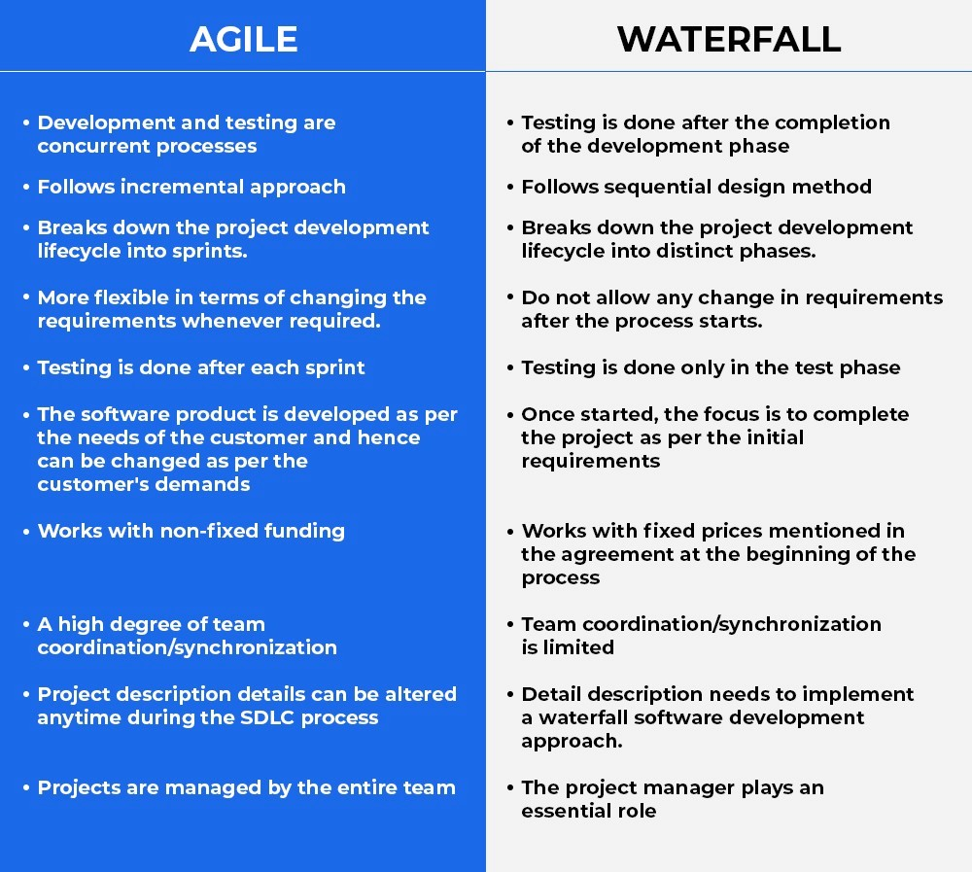

**—--------------------------------------------------------------------------------------------------------------**

* 1. **Discuss in detail about DevOps eco system. [10M]**

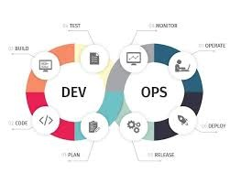

The  **DevOps ecosystem**  refers to the tools, practices, and principles that organizations use to achieve continuous integration, continuous delivery, and collaboration between development (Dev) and operations (Ops) teams. The goal of this ecosystem is to streamline and automate the entire software development lifecycle, enabling organizations to deliver high-quality software faster, with more collaboration and efficiency.

Here’s a detailed breakdown of the DevOps ecosystem:

## 1 . Collaboration and Communication Tools

* **Purpose** : At its core, DevOps is about fostering a culture of collaboration between development, operations, and other stakeholders, ensuring that teams work together efficiently.
* **Tools** : Tools for communication and collaboration support cross-functional team interactions and project management. These tools break down silos, track work, and keep all teams aligned on goals.

○ **Examples** :

■ **Slack** : A communication platform to connect teams and streamline discussions.

## 2. Version Control Systems (VCS)

* **Purpose** : Version control systems are used to manage source code, enabling developers to track and collaborate on code changes.
* **Tools** : These tools allow code to be stored and versioned so that teams can manage changes over time and coordinate their work. ○  **Examples** :

**Git** : A distributed version control system that enables developers to

track

## 3 . Continuous Integration (CI) and Continuous Deployment (CD)

**Purpose** : CI/CD is the backbone of the DevOps pipeline, enabling automatic integration, testing, and deployment of code to ensure faster and reliable delivery of software.

**Tools** : These tools automate the building, testing, and deployment processes, allowing teams to detect issues early and deliver new features faster.

○  **Examples** :

**Jenkins** : A widely-used CI/CD tool that automates building, testing, and deployment pipelines.

## 4. Automated Testing Tools

**Purpose** : Testing is a critical part of the DevOps pipeline, ensuring that software quality is maintained even when the code is changing rapidly.

**Tools** : Automated testing tools help developers write tests that can be automatically run as part of the CI/CD pipeline, detecting bugs early.

○ **Examples** :

**Selenium** : An open-source tool for automating web application testing.

## 5 . Infrastructure as Code (IaC)

**Purpose** : Infrastructure as Code allows infrastructure ( servers, networks, databases, etc.) to be managed and provisioned using code, enabling versioning, automation, and consistency across environments.

**Tools** : IaC tools help automate the deployment and management of infrastructure, ensuring consistency and scalability.

○ **Examples** :

**Terraform** : An open-source IaC tool that allows developers to define and provision infrastructure using a high-level configuration language.

—----------------------------------------------------------------------------------

3. List and explain the steps followed for adopting DevOps in IT projects? [10M]

A.Adopting DevOps in IT projects involves a set of steps to integrate development and operations teams in a collaborative and efficient environment. The following steps outline a typical process for adopting DevOps practices in IT projects:

### 1 . Understand and Define DevOps Culture

**Explanation** : DevOps is not just about tools but about fostering a culture of collaboration between development, operations, and other teams involved in the software lifecycle. Understanding this cultural shift is essential for the successful adoption of DevOps practices.

**Key Action** : Educate all stakeholders on the benefits of DevOps, emphasizing shared responsibilities, accountability, and communication. Encourage collaboration across silos between development, operations, and QA teams.

### 2. Assess Current Processes and Tools

**Explanation** : Before implementing DevOps practices, organizations need to assess their existing workflows, tools, and practices. This helps to identify inefficiencies and areas for improvement.

**Key Action** : Review the current CI/CD pipeline, version control, deployment procedures, and infrastructure. Identify bottlenecks, communication issues, or delays in the software delivery process that can be improved with DevOps.

### 3 . Set Clear Objectives and KPIs

**Explanation** : Having clear goals ensures that the DevOps adoption process aligns with business objectives and that progress can be measured.

**Key Action** : Establish specific metrics (KPIs) to track success. These can include deployment frequency, lead time for changes, mean time to recovery (MTTR), and customer satisfaction. Setting goals ensures a data-driven approach to measuring improvements over time.

### 4 . Automate and Streamline Development and Deployment Processes

**Explanation** : Automation is a cornerstone of DevOps. Automating repetitive tasks like testing, deployment, and infrastructure management increases efficiency, reduces errors, and accelerates the delivery pipeline.

**Key Action** : Implement Continuous Integration (CI) and Continuous Deployment ( CD) tools to automate the testing and deployment phases of the software lifecycle. Tools like Jenkins, GitLab CI, or CircleCI can help automate the build, test, and release processes.

### 5. Improve Collaboration and Communication

**Explanation** : Communication and collaboration between development, operations, and other stakeholders are crucial for DevOps success.

**Key Action** : Use collaboration tools (e.g., Slack, Jira, or Trello) to facilitate communication and track progress. Regular stand-up meetings or cross-team sync-ups ensure that everyone stays aligned with project goals and timelines.

### 6. Integrate Continuous Testing

**Explanation** : Continuous testing ensures that code is always validated before it moves to production, reducing the chances of errors and improving software quality.

**Key Action** : Implement automated testing practices like unit tests, integration tests, and acceptance tests as part of the CI/CD pipeline. Testing should occur at every stage, from development to production, ensuring code quality at all times.

secure coding, secure configuration management, and compliance checks throughout the software lifecycle.

Set 4

1. Explain the values and principles of Agile model. [10M]

A.The  **Agile model**  is a popular methodology used in software development that emphasizes flexibility, collaboration, customer feedback, and delivering working software iteratively and incrementally. It aims to respond to changing requirements over time, offering a more adaptive and flexible approach to project management and software development compared to traditional methodologies.

## Values of the Agile Model

The Agile Manifesto outlines four key values:

1. . **Individuals and Interactions over Processes and Tools** :

**Explanation** : While processes and tools are important, Agile prioritizes people and their interactions as the core to delivering value. Effective communication and collaboration among team members, customers, and stakeholders are seen as more important than strictly following processes or relying too heavily on tools.

**Implication** : Teams are encouraged to work together closely, adapt their communication based on context, and choose tools that best serve their needs rather than adhering to rigid, predefined processes.

1. . **Working Software over Comprehensive Documentation** :

**Explanation** : Agile values delivering working software that meets the needs of customers and users rather than spending too much time on extensive documentation. While documentation is still necessary, the focus is on producing tangible, functioning software that delivers value to users.

**Implication** : Teams aim to create incremental, usable versions of the product frequently, which helps ensure that the software is aligned with evolving customer needs.

1. **Customer Collaboration over Contract Negotiation** :

**Explanation** : Agile emphasizes continuous collaboration with the customer (or stakeholders) rather than relying on lengthy contract negotiations. This ensures that the software developed meets the real, evolving needs of the customer rather than rigid contractual requirements that may become outdated or misaligned.

**Implication** : Agile teams engage in regular feedback loops with customers, stakeholders, or end-users to ensure that the product is evolving in the right direction and to quickly adapt to new requirements.

1. **Responding to Change over Following a Plan** :

**Explanation** : Agile acknowledges that requirements, technologies, and priorities can change during the project, and the ability to adapt is more important than sticking to a detailed, fixed plan. Agile promotes flexibility in responding to changes as they arise during the development process.

**Implication** : Teams are expected to be flexible and ready to embrace changes, including adjustments in scope, design, or functionality, rather than following a rigid plan that may no longer be relevant or beneficial.

## Principles of the Agile Model

The Agile Manifesto also outlines 12 principles that further define how Agile teams should approach software development:

1. .  **Customer Satisfaction through Early and Continuous Delivery of Valuable Software** :

Focus on delivering usable software to the customer as early as possible and continue delivering small, valuable increments frequently to keep the customer satisfied.

1. . **Welcome Changing Requirements, Even Late in Development** :

Agile welcomes change, even if it comes late in the development process. This flexibility allows the product to meet customer needs better as they evolve.

1. . **Deliver Working Software Frequently, with a Preference for Shorter Timescales** :

Software should be delivered in short cycles (e.g., every 1-4 weeks), ensuring that the development process is flexible, iterative, and that stakeholders can see tangible progress frequently.

1. **Business and Developers Must Work Together Daily** :

Agile promotes close collaboration between business stakeholders and development teams. This ensures that development is aligned with business needs and priorities.

1. **Build Projects Around Motivated Individuals** :

Agile believes in giving teams the environment, support, and trust they need to get the job done. Motivated individuals lead to better performance, so fostering team autonomy is crucial.

6 . **Face-to-Face Communication is the Most Efficient and Effective Method** :

Agile values face-to-face communication as the most effective way of conveying information and resolving issues, promoting collaboration and quick decision-making.

1. **Working Software is the Primary Measure of Progress** :

Instead of measuring progress with traditional metrics like lines of code or hours worked, Agile measures success based on the delivery of working software that meets customer needs.

1. **Agile Processes Promote Sustainable Development** :

Agile encourages a sustainable pace of work. Development teams should be able to maintain a steady and manageable pace, avoiding burnout and ensuring long-term productivity.

1. .  **Continuous Attention to Technical Excellence and Good Design Enhances**

**Agility** :

High-quality software with a focus on technical excellence and good design makes it easier to adapt to changes, minimize defects, and maintain the software in the long run.

1. .  **Simplicity – The Art of Maximizing the Amount of Work Not Done – Is**

**Essential** :

Agile emphasizes simplicity in both code and processes, encouraging teams to focus on the most important features and avoid unnecessary work.

1. .  **The Best Architectures, Requirements, and Designs Emerge from Self-Organizing Teams** :

Agile promotes self-organizing teams, where the team members collectively make decisions based on their expertise and understanding of the problem. This leads to better, more innovative solutions.

12.  **Regular Reflection and Adjustment for Continuous Improvement** :

Teams should reflect regularly on their performance and processes (typically through retrospectives) and make adjustments as needed to improve efficiency and effectiveness over time.

—-------------------------------------------------------------------------------------------

2.Write a short notes on the DevOps Orchestration

A. **DevOps Orchestration**  refers to the automated coordination of various tools, processes, and workflows in the DevOps pipeline to streamline and manage the entire software development lifecycle, from code development to deployment and operations. It focuses on automating complex tasks, ensuring efficiency, consistency, and improved collaboration between development and operations teams.

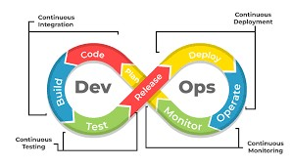

**Key Aspects of DevOps Orchestration:**

1.  **Automation of Workflows** :

DevOps orchestration enables the automation of repetitive tasks, such as building, testing, deploying, and monitoring applications. It ensures that these processes run smoothly without manual intervention, reducing errors and saving time.

1. . **Integration of Tools** :

A key aspect of orchestration is integrating various DevOps tools across the pipeline. Tools for version control, CI/CD, infrastructure management, testing, monitoring, and security must be seamlessly connected. Orchestration ensures these tools work together as a cohesive system.

Examples of tools integrated through orchestration: Jenkins (CI/CD), Docker (containerization), Kubernetes (orchestration of containers), Terraform (infrastructure automation), and Prometheus (monitoring).

1. . **Configuration Management** :

Orchestration includes the management of infrastructure configurations, ensuring consistency across different environments (e.g., development, staging, and production). Tools like  **Ansible** ,  **Chef** , and  **Puppet**  are commonly used for configuration management as part of orchestration.

1. **Improved Collaboration** :

Through orchestration, development and operations teams can collaborate more efficiently. It reduces friction between teams by automating deployments and ensuring consistency across environments, enabling faster releases and fewer deployment errors.

1. **Scalability and Flexibility**:

DevOps orchestration tools can scale as needed to handle increasing workloads. This is particularly important for cloud-native applications where scaling is essential for handling varying levels of traffic. Kubernetes is one popular tool for automating container orchestration at scale.

1. **Monitoring and Feedback** :

Orchestration integrates monitoring and logging tools into the DevOps pipeline to continuously track performance, detect issues, and provide real-time feedback. This enables rapid issue resolution and continuous improvement in the software delivery process.

—-------------------------------------------------------------------------------------------

3.What is the difference between Agile and DevOps models?

A.

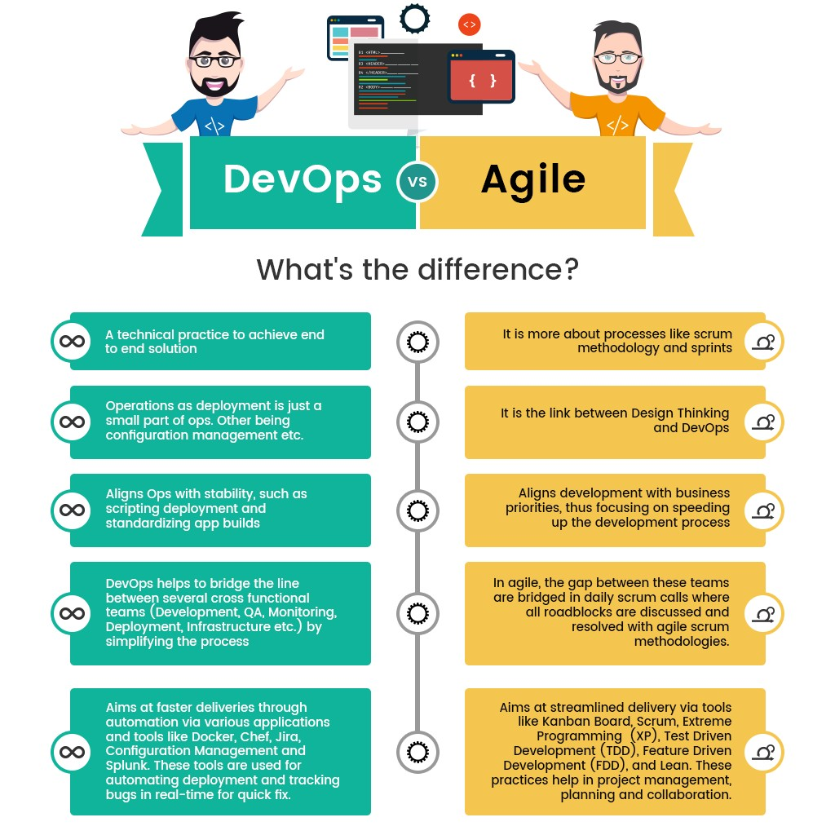

— THE END —